Udacity Machine Learning Nanodegree 2020

Capstone Project Report

Neural-Network based Mortgage Prepayment Model

Yuri Turygin

November 2020

1 Problem Statement

In this project we build a neural network-based prepayment model designed to predict the rates at which mortgage borrowers repay their mortgage loans depending on a variety of factors. These repayment rates are called mortgage prepayment speeds. Let us explain how exactly we calculate them.

When a borrower makes her monthly mortgage payment, a part of the payment goes towards paying off interest and another part goes towards paying off mortgage principal. Each month we know exactly how much principal should be left after a borrower makes her payment. That is actually decided at the time of the mortgage origination and this principal repayment schedule is called mortgage amortization schedule. Suppose, the scheduled remaining principal balance after the Nth payment on a mortgage loan is CN, but a borrower has made a payment higher than the necessary by an amount of pN, then we define a Single Month Mortality (SMM) rate SMMN to be

${SMM}_{N}=\frac{p_{N}}{C_{N}}$.

In other words, we measure prepayment speeds as percentage points of the outstanding principal balance. Note that higher than scheduled mortgage payment does not decrease the scheduled mortgage principal for the next month, because the extra payments are applied towards the tail of a mortgage. For example, if you had 100 mortgage payments left, but one month you made two mortgage payments instead of one, then all is different is that you don’t need to make your 100th mortgage payments anymore. Thus, the above definition makes sense irrespective of prepayments observed in the previous months.

Although the model we are going to build is designed to predict SMM, people rarely discuss prepayment speeds in SMM units. It is much more common to discuss mortgage prepayment speeds using an annualized version of SMM called CPR (Constant Prepayment Rate). SMM and CPR are connected via the following simple formula.

$$CPR=1-{(1-SMM)}^{12}$$

In other words, CPR shows the percentage of the principal loan balance to be gone in one year if prepayment speeds remain the same every month for a year.

Government Sponsored Enterprises (GSEs), such as Fannie Mae, are making a lot of mortgage prepayment data available on a monthly basis, because that data is required to calculate cashflows on many mortgage bonds and therefore, is an essential information for mortgage investors to know. The data consists of monthly snapshots of characteristics and prepayment speeds of all mortgage pools whose credit risk (risk of borrower’s default) is guaranteed by a GSE, in this case by Fannie Mae. Besides the monthly pool prepayment speeds, which we discussed above, the data contains many of the average characteristics of borrowers in a pool. Among the few of those are an average of loan sizes on loans in a pool, an average FICO score, average age of loans, what percentage of loans were originated in a given state, who’s servicing the loan, and many more. We will use all of that data to build a model which will make prepayment speeds predictions.

More specifically, our dataset consists of all Fannie Mae guaranteed mortgage pools originated in 2010 and later with each pool containing at least 250 loans. That will make the size of the dataset a lot more manageable.

We will calibrate our model to prepayment experience observed in 2010-2016, and then test our model on prepayment experience of 2017 – Feb 2020.

2 Analysis

One of the most important factors in mortgage prepayments is refinancing incentive. An incentive to refinance on a loan is defined as (mortgage rate – prevailing mortgage rate available in the market at a time). We measure prepayment incentive in basis points. For example, if borrowers in a pool on average pay a 4% mortgage rate, but the prevailing mortgage rate in the market is 3%, then we say that a pool has 100 bps (=1%) rate incentive. In the data that we use rate incentive is called “spread”.

What is “prevailing mortgage rate”? Basically, it a common mortgage rate in the market at any given time. The industry standard is to use Freddie Mac’s weekly Primary Mortgage Market Survey (PMMS) rate, which is published on Thursdays at 10am here <http://www.freddiemac.com/pmms/>. Think of it as an average mortgage rate in the country for that week. We use an 8-weeks average of PMMS rates for 8 weeks prior to an observed prepayment event to calculate the prevailing mortgage rate, and therefore, the rate incentive.

It should be intuitively obvious that the higher the rate incentive the more likely a loan to refinance. This can easily be seen in the data. See below a snapshot of prepayment speeds on 10,000 randomly chosen mortgage pools depending on rate incentive (“spread”) and stratified by an average loan sizes of pools. What we see here is twofold -- higher rate incentives do correspond to higher prepayment speeds (SMM) and also higher loan sizes at same levels of incentive typically correspond to even higher prepayment speeds. It makes sense, because borrowers with bigger mortgages save more dollars by refinancing into a lower rate than borrowers with lower mortgage balances.

Another example for how prepayment speeds depend on mortgage pool characteristics is to show prepayment speeds depending on what percentage of loans in a pool are investor loans. Investor loans are much more expensive to originate than non-investor loans due to higher fees that GSEs require to guarantee their credit risk. As a result, they tend to refinance a lot less than non-investor loans for the same level of rate incentive. This phenomenon can be easily observed on the graph below.

Finally, prepayment speeds on a pool of mortgages can depend on factors other than characteristics of the loans themselves. For example, prepayment speeds can be vastly different depending on who has originated those loans in the first place. The prime example for that is loans that have been originated by Quicken, see graph below.

Quicken speeds tend to be much faster than similar pools of loans originated by other servicers. As a matter of fact, there are servicers who are “slower” than average and sometimes by a lot. That is why it is important to include servicing composition of a pool as factors to drive the model predictions. Our data includes fields showing what percentage of loans has been originated by a particular mortgage originator. We have this information for the top 22 industry leading mortgage originators.

It is evident from the discussion above that mortgage prepayments depend on a variety of factors which are many and some of the dependencies are quite complex. It should also be noted that what we are trying to predict here is borrower’s behavior, which can be and often is non-linear in nature. Therefore, our model has to be very flexible, capable of fitting complex dependencies between model factors, and therefore, most likely has many parameters.

A typical approach to prepayment modeling is to build a parametric model of the form

With each function modeling that one specific factor . The factors are typically fitted sequentially thru least squared errors approximation.

The approach above has its advantages and disadvantages. The advantages are that each factor in the model is easily understood and can be tweaked, if necessary. The disadvantages are in that one has to know beforehand what the factors should be an in which order they should be fitted. The later part is usually done through an extensive data exploration phase and for that reason prepayment models sometimes take many months to develop. The other disadvantage is that one has to pick a parametrization function for each factor. For the most part it is fine, and model produces satisfactory results, but then also model “sees” only what you “tell” it to “see”.

With this neural-network modeling approach we are trying to address the speed of development and model flexibility issues at the expense of model transparency, because neural-networks after all are kind of a black box.

3 Implementation

We built a feed-forward neural network consisting of five layers with four hidden layers and one output layer. The network has the following general architecture.

1st hidden layer (512 neurons) , ‘relu’ activation [0.5 dropout rate used during fitting]

⇓

2nd hidden layer (256 neurons) , ‘relu’ activation [0.5 dropout rate used during fitting]

⇓

3rd hidden layer (128 neurons) , ‘relu’ activation [0.5 dropout rate used during fitting]

⇓

4th hidden layer (64 neurons) , ‘relu’ activation [0.3 dropout rate used during fitting]

⇓

Output layer, 1 neuron, ‘relu’ activation

In our implementation we have used Keras API into Tensorflow and specifically Sequential model. For model fitting we have used “Adam” optimizer with ‘mse’ loss function. To speed up the model calibration process we have used a batch optimization algorithm with a batch size of 1024. The calibration was done over 300 epochs.

All hyper parameters used in the model were chosen through a trial and error process, i.e. through examining the goodness of the model fit on a train set vs. the performance of the model on a test set.

As stated in the 1st section above, for the train set we have used the prepayment experience of 2010 thru 2016, and for the test set we have used the prepayment experience of 2017 thru Feb of 2020.

The model was coded up in a Jupyter Notebook and supplied in current repository under filename model_fitting.ipynb.

The data used in the model fitting contained 101 features (columns) with only one of them being a categorical variable. That variable was “Seasonality” which is the month of the year during which a prepayment even has occurred. It turns out that borrowers tend to refinance their mortgages more often in the summer and less often in winter. Prepayment speeds can differ by 10-15% depending on the time of year all else equal. Hence, “Seasonality” is an important factor in the model. Because of this one categorical variable, the number of features in the model grew to 111.

4 Results

The model is fitting previous prepayment experience quite nicely and appears to have a good predictive power into the future as evidenced by the in/out of sample comparisons below. Here we show the model performance on the in sample or test population (2010 thru 2016 prepayment experience) and on the out of sample (2017 – Feb 2020) prepayment experience. The pools in the graph below are stratified by the %coupon that is paid to a mortgage investor. They usually appear in the increments of 0.5%. Below we have 2.5%, 3%, 3.5%, 4%, 4.5%, 5% mortgage pools. For a mortgage pool which is paying X% coupon, the average mortgage rate that borrowers are paying is typically 50-100 bps higher. It is natural to stratify our pools by coupon, because that is just how mortgage bond market trades, and also because prepayments speeds on different coupon bonds will be significantly different. Higher coupon bonds will have higher average borrower’s mortgage rates and therefore, higher rate incentive. So, prepayment speeds on them will be higher.

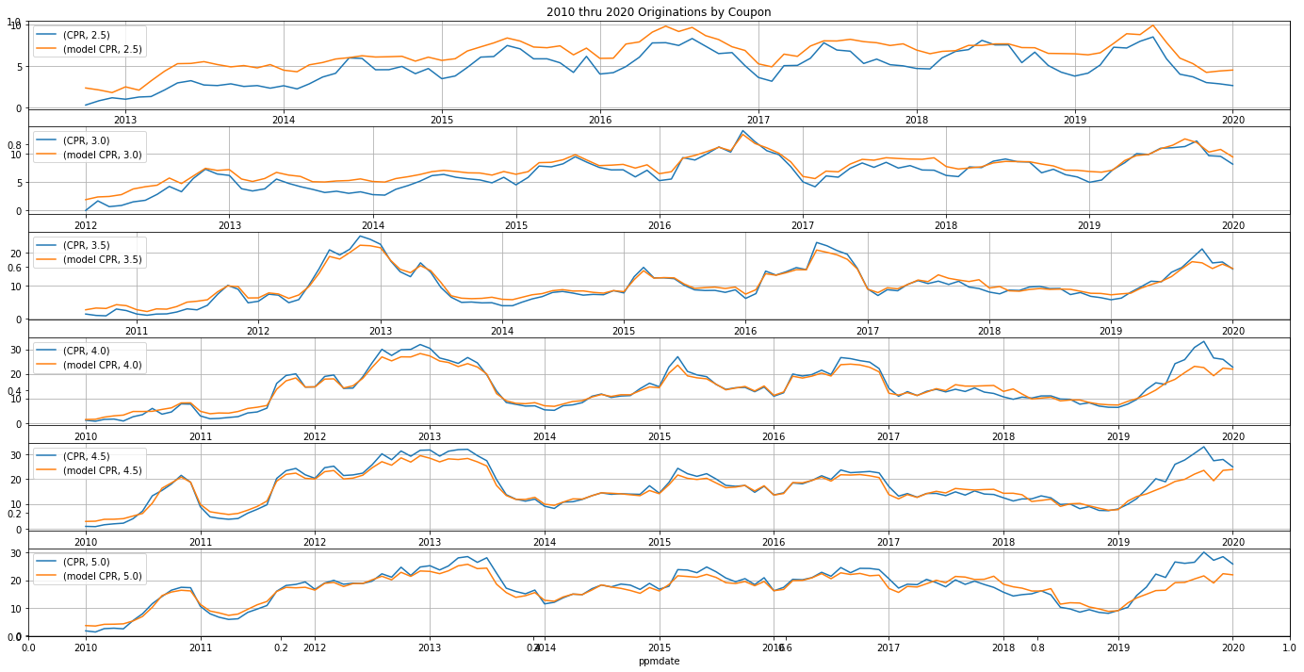

As seen on the graph above, the model fits the historical data quite nicely even during the out of sample period. The biggest problem is in higher coupons through the end of the 2019, when mortgage rates have dropped, and prepayment speeds increased quite sharply. The model is not fitting that period well for 4%, 4.5%, and 5% coupons. However, if we restrict our population to the so called loan balance pools (pools consisting of loans with less than 200k outstanding loan balance), the model performance improves quite a bit, see the next graph below.

The model also performs quite well on the so called “Cash Window” pools, which are pools consisting of loans originated by very small originators.

The model shows a quite decent performance on the investor loans as well, see graph below.

A particular good model performance is observed on primarily “Retail” pools. These are pools of mortgages consisting of loans originated through a retail origination channel, so not through a Broker or a Correspondent. Think of these loans as originated by a bank itself (what bank? Any big bank). Retail loans usually behave quite tamely when compared to Broker and Correspondent loans, because Brokers make money on fees from loan originations, while banks also make money on loan servicing. Therefore, Broker tend to solicitate their clients more aggressively than banks on average. So, it’s not surprising that Retail loans are easier to model.

5 Conclusions

In this project we have built a neural network-based mortgage prepayment model and have showed that such a model has a satisfactory predictive power and its output depends on model inputs in a way that makes economic sense. The relative speed with which such models can be developed can give a desirable advantage to any mortgage investor who wants to be able to adjust to regime changes in the mortgage market as quickly as possible and to risk manage her mortgage assets in a more accurate way.